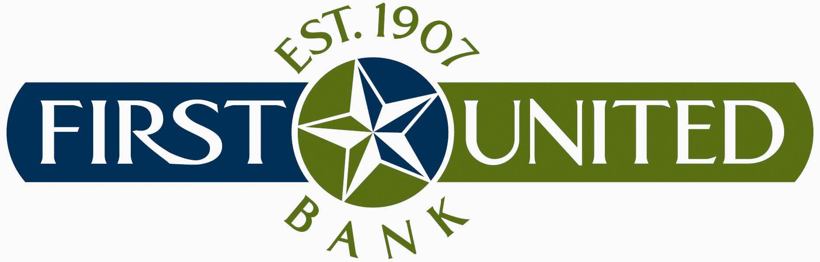

LOAN PRODUCTS

The specific types of credit that First United Bank is prepared to extend to its communities, in a manner consistent with safe and sound operations, are as follows:

Real Estate Loans

Land Development

Construction

Permanent Mortgages

Commercial and Community Development

Home Improvement

Home Equity (through Mortgage Department)

Adjustable Rate Mortgages

Bank Charge Cards (through third party)

Agricultural Loans

Farm Operating Lines

Term Loans (Secured by equipment, sprinklers, etc.)

Cattle Operating Lines

FSA Guaranteed Loans, FSA Subordinates and Loan Note Guarantees

Farm Land

Consumer Loans

Unsecured

Motor Vehicle (Direct)

Non-title Securities (Furniture-purchase money only and Equipment)

Secured by Savings or Certificates of Deposit

Secured by Stocks or Bonds

Secured by Cash Surrender Value of Insurance

Boats or Recreational Vehicles

Aircraft

Home Improvement

Equity (see number 6 Real Estate Loans)

Housing Rehabilitation

Commercial Loans

Unsecured

Secured by Stocks or Bonds

Secured by Marketable Inventory, Contract Rights, Current Accounts Receivable, and Equipment

Secured by Savings or Certificates of Deposit

Secured by Cash Surrender Value of Insurance

Intermediate Term Business Loans

Small Business Loans (Primarily Under Small Business Administration Insured Programs)

Oil and Gas

Commercial Real Estate (strip center, office buildings etc…)

