

**Branch Locations**

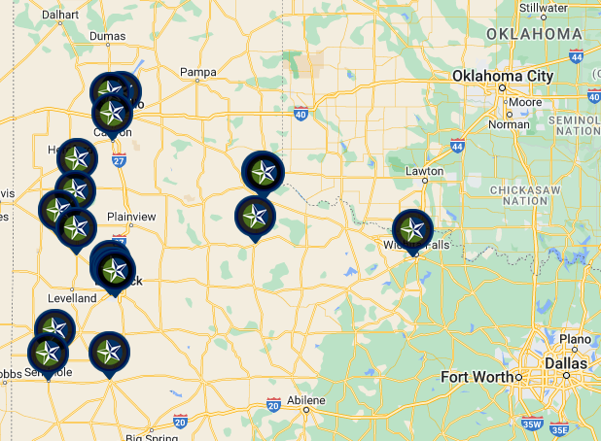



|  |  |  |  |  |  |  |
| --- | --- | --- | --- | --- | --- | --- |
| **BRANCH LOCATION** | **ADDRESS** | **INCOME LEVEL** | **GEOGRAPHY** | | **ATM / TLR CHT** | |
| **COUNTY** | **CENSUS TRACT** | **ATM** | **TLR CHT** |
| **AMARILLO MSA 11100** | | | | | | |
| The Colonies Banking Center | One First United Bank Pkwy Amarillo, Tx 79119 | Upper | Randall / 381 | 0216.09 | Yes | Yes |
| Tradewind Banking Center | 1900 SE 34th Avenue Suite 100  Amarillo, Tx 79118 | Middle | Randall / 381 | 0220.02 | Yes | Yes |
| **CANYON MSA 11100** | | | | | | |
| Canyon Banking Center | 801 23rd Street  Canyon, Tx 79015 | Middle | Randall / 381 | 0218.02 | Yes | Yes |
| **Childress Non-MSA** | | | | | | |
| Childress Main | 301 Main St  Childress, TX 79201 | Moderate | Childress / 075 | 9502.00 | No |  |
| **COTTLE Non-MSA** | | | | | | |
| Paducah | 704 10th St  Paducah, TX 79248 | Moderate | Cottle / 101 | 9501.00 | Yes |  |
| **DIMMITT NON‐MSA** | | | | | | |
| Dimmitt Banking Center | 201 North Broadway  Dimmitt, TX 79027 | Middle | Castro / 069 | 9502.00 | Yes | Yes |
| **EARTH NON‐MSA** | | | | | | |
| Earth Banking Center | 220 East Main Street Earth, Tx 79031 | Middle | Lamb / 279 | 9502.00 | No |  |
| **LAMESA NON‐MSA** | | | | | | |
| Lamesa Banking Center | 602 North First Street Lamesa, Tx 79331 | Middle | Dawson / 115 | 9505.00  Rural or Underserved | Yes | Yes |
| **LITTLEFIELD NON‐MSA** | | | | | | |
| Littlefield Banking Center | 2003 South Hall Ave Littlefield, Tx 79339 | Middle | Lamb / 279 | 9506.00 | Yes | Yes |
| **LUBBOCK MSA 31180** | | | | | | |
| Northwest Banking Center | 5802 4th Street  Lubbock, Tx 79416 | Middle | Lubbock / 303 | 0104.17 | Yes | Yes |
| Southwest Banking Center | 6604 Frankford Avenue  Lubbock, Tx 79424 | Upper | Lubbock / 303 | 0017.17 | Yes | Yes |
| Southeast Banking Center | 9801 Indiana Ave  Lubbock, Tx 79423 | Middle | Lubbock / 303 | 0105.11 | Yes | Yes |
| **SEAGRAVES NON‐MSA** | | | | | | |
| Seagraves Banking Center | 106 Main  Seagraves, Tx 79359 | Middle | Gaines / 165 | 9501.00 | Yes | Yes |
| **SEMINOLE NON‐MSA** | | | | | | |
| Seminole Banking Center | 601 NW Avenue B Seminole, Tx 79360 | Upper | Gaines / 165 | 9503.00 | No |  |
| **SUDAN NON‐MSA** | | | | | | |
| Sudan Banking Center | 200 Main  Sudan, Tx 79371 | Middle | Lamb / 279 | 9503.00 | No |  |
| **WICHITA FALLS MSA 48660** | | | | | | |
| Wichita Falls Banking Center | 2904 Garnett  Wichita Falls, Tx 76308 | Middle | Wichita / 485 | 0120.02 | No |  |